**CE101 Engineering Drawing July- Nov 2019**

**Indian Institute of Technology Guwahati**

**Lab Sheet-9 Development of Surfaces Tuesday Afternoon**

**Full Marks: 100 Date:22.10.2019**

1. Draw the development of the complete surface of a 45 mm high frustum of a square prism of base and top edge length of 50 mm and 25 mm (15 Marks)
2. Draw the development of the lateral surface of the cylinder of 45 mm diameter as shown in figure below. (35 Marks)

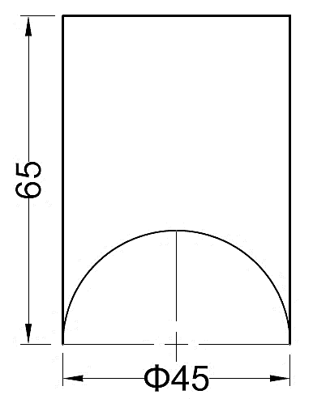

1. A hexagonal prism made of metal sheet with cut marks on its faces has its development as shown in figure below. Draw the projections of the hexagonal prism formed by wrapping the metal sheet such that the axis is perpendicular to the HP and a face is parallel to the VP. Also, show the cut face in the FV.

(50 Marks)

